1. Problem 9.6
2. -53.51 represents the increase of mortgage rate by 1 from (t-2)th to (t-1)th period will lead to decrease in the number of new homes sold from (t-1)th to t period by 53510.

95% interval for the coefficient of DIRATEt-1:

T(0.975, 216) = 1.971 for degree of freedom = 218-2= 216

-53.51 – 16.98 * 1.971 = -86.98

-53.51 + 16.98 * 1.971 = -20.04

95% interval = [-86.98, -20.04]

1. Assume  = 0.05,

(i) LM= T * R2 = 218 * 0.1077 = 23.48 > X2 (0.95,1) = 3.84, so we reject H0, accepting that residual et is serially correlated.

(ii) T = -0.3306/0.0649 = -5.094 < T(0.025, 216) = -1.97, so we reject H0, accepting the coefficient of et-1 is not zero (statistically significant)

1. 95% interval for the coefficient of DIRATEt-1:

T(0.975,215) = 1.971,

-58.61 - 1.971 * 14.1 = -86.40

-58.61 +1.971 * 14.1 = -30.82

95% interval = [-86.40, -30.82]

Ignoring autocorrelation may lead to wrong confidence interval and wrong inferences, in this case, 95% interval = [-86.40, -30.82] when considering autocorrelation vs. [-86.98, -20.04] when ignoring autocorrelation

1. Problem 10.4
2. Y = 1 + x + e

> xe=read.csv("ivreg1.csv")

> x=xe$x

> e=xe$e

> y = 1+x+e

> y

[1] -0.94726 0.59811 2.20424 -0.80192 -2.44085 5.98294 1.04577 0.95068

[9] 1.22507 4.18151 0.99779 1.93794 -3.50009 -3.65135 -0.20259 1.93985

[17] 1.27188 -1.71158 0.79685 0.49647 -1.38755 0.94821 1.53969 1.38511

[25] 3.53402

> plot(xe)

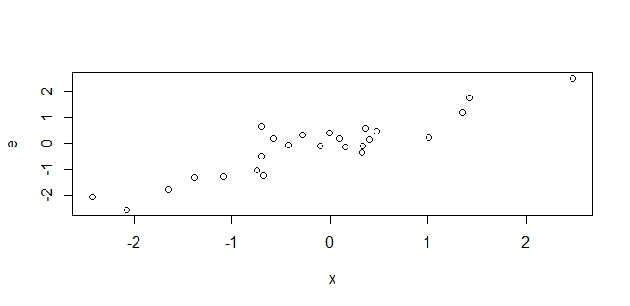b) > plot(x,y)

> abline(1,1)

The errors seem not randomly distributed. The errors become large When |X|large

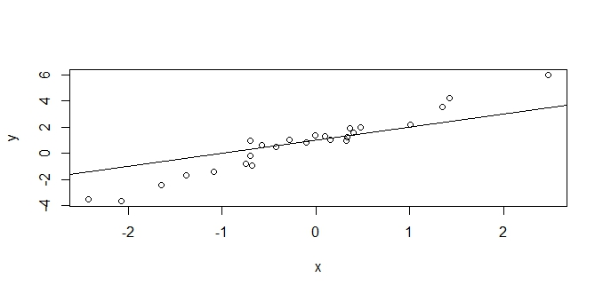

1. > summary(lm(y~xe$x))

Call:

lm(formula = y ~ xe$x)

Residuals:

Min 1Q Median 3Q Max

-0.76087 -0.29414 -0.00732 0.22828 1.30921

Coefficients:

Estimate Std. Error t value Pr(>|t|)

(Intercept) 1.00087 0.09956 10.05 6.92e-10 ***

xe$x 1.94902 0.09034 21.57 < 2e-16 ***

---

Signif. codes: 0 ‘***’ 0.001 ‘**’ 0.01 ‘*’ 0.05 ‘.’ 0.1 ‘ ’ 1

Residual standard error: 0.4914 on 23 degrees of freedom

Multiple R-squared: 0.9529, Adjusted R-squared: 0.9509

F-statistic: 465.4 on 1 and 23 DF, p-value: < 2.2e-16

b1 = 1 , b2= 1.949, the estimated value of parameter 2 (b2=1.949) is larger than the true value 1



> b1= coef(lm(y~xe$x))[1]

> b2= coef(lm(y~xe$x))[2]

> yhat = b1 + b2*xe$x

> plot(x,yhat)

> abline(lm(yhat~x))

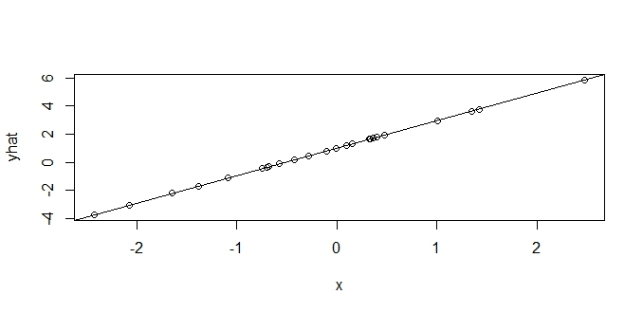

This fitted least square line is steeper than the true regression line of E(y) = 1 + x in (b)

> resid = y - yhat

> d= data.frame(x,e,resid)

> cor(d)

x e resid

x 1.000000e+00 0.9096781 -2.015515e-16

e 9.096781e-01 1.0000000 4.153141e-01

resid -2.015515e-16 0.4153141 1.000000e+00

We can see Cor(x,e) = 0.909678. There is high correlation between X and e. When there is correlation between X and e, we could not use the sampled data for regression.

1. Problem 12.4

> oiltable = read.csv("oil.csv")

> series = 1883:1970

> plot(series,oiltable$oil, xlab="Year", ylab="Oil Price", type="o")

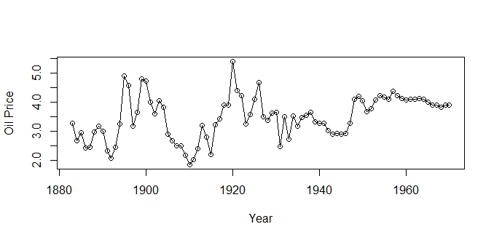

It looks stationary.

1. Unit root test

> library("urca")

> x=ur.df(oiltable$oil,type="drift", lags=0)

> summary(x)

###############################################

# Augmented Dickey-Fuller Test Unit Root Test #

###############################################

Test regression drift

Call:

lm(formula = z.diff ~ z.lag.1 + 1)

Residuals:

Min 1Q Median 3Q Max

-1.13305 -0.27376 0.05875 0.22239 1.60691

Coefficients:

Estimate Std. Error t value Pr(>|t|)

(Intercept) 0.94249 0.26373 3.574 0.000583 ***

z.lag.1 -0.26908 0.07423 -3.625 0.000492 ***

---

Signif. codes: 0 ‘***’ 0.001 ‘**’ 0.01 ‘*’ 0.05 ‘.’ 0.1 ‘ ’ 1

Residual standard error: 0.5078 on 85 degrees of freedom

Multiple R-squared: 0.1339, Adjusted R-squared: 0.1237

F-statistic: 13.14 on 1 and 85 DF, p-value: 0.0004919

Value of test-statistic is: -3.6247 6.5778

Critical values for test statistics:

1pct 5pct 10pct

tau2 -3.51 -2.89 -2.58

phi1 6.70 4.71 3.86

test-statistic = -3.6247 < tau = -3.51 at  = 1%, so we reject H0 and accept H1 :  < 0 ( <1) , the series is stationary.

c) Order of integration = 0 because the series itself is stationary.